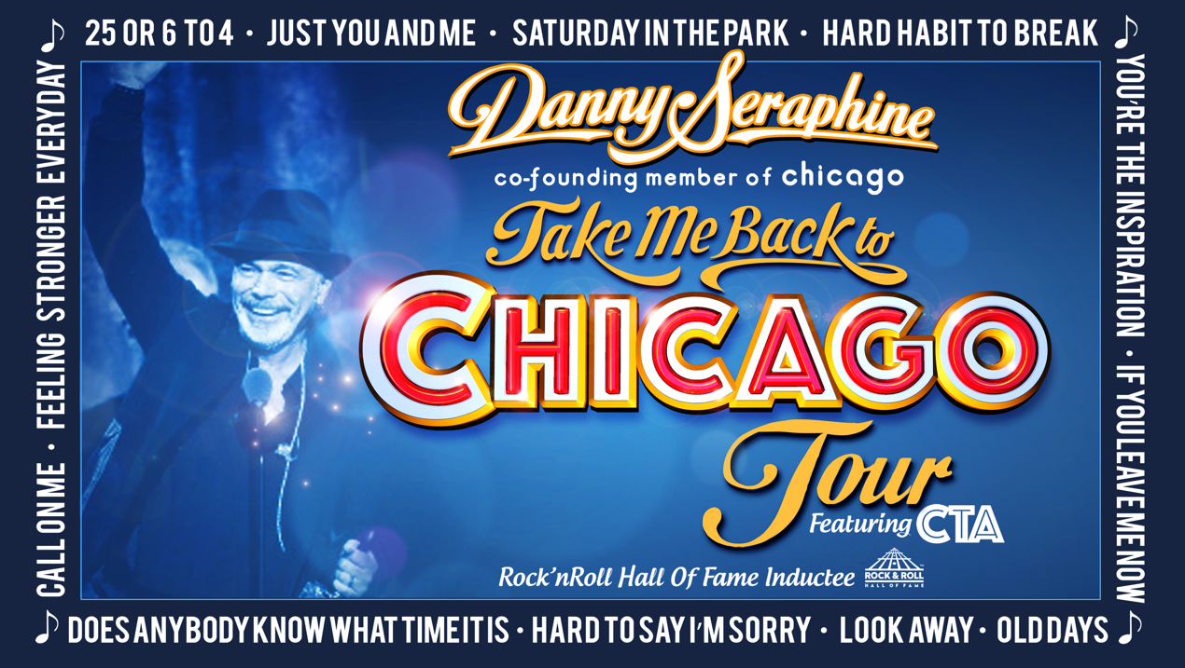
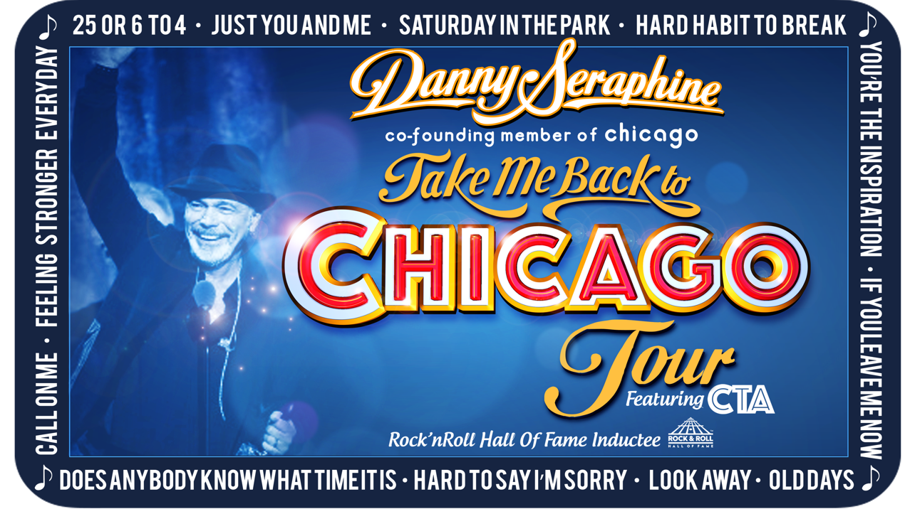
Headline: Chicago Co-Founding Member Danny Seraphine’s “Take Me Back to Chicago Tour” Available for Immediate Release
The timeless music of Chicago comes to life with CTA featuring Rock and Roll Hall of Famer and Co-Founding member of Chicago, Danny Seraphine. This world-class band combined with a thunderous horns section perform many of Chicago’s classic hits from the 70’s like 25 or 6 to 4, Feeling Stronger, and Saturday in the Park and also includes the 80’s power ballad era including Hard Habit to Break, You’re the Inspiration, and Look Away. It’s a night of nothing but classic hit music that you sure won’t want to miss, with Danny Seraphine’s “Take Me Back to Chicago Tour”.

Based in Los Angeles, CTA masterfully blends rock and jazz music while being fueled by the creative passion and pure percussive power of drummer, Danny Seraphine. Whether performing Chicago classics or the CTA originals written by Danny himself and acclaimed guitarist Marc Bonilla, CTA is sure to deliver an earth-shaking performance that you won’t forget. The bands 2008 debut, Full Circle, garnered rave reviews and spawned some now-legendary CTA live performances.

The “Take Me Back to Chicago Tour” will delve deep into the pivotal music of rock band Chicago, exploring their unique blend of musical styles while providing an absolutely unbeatable concert experience. Be sure to book this historic group immediately, while they are still available!

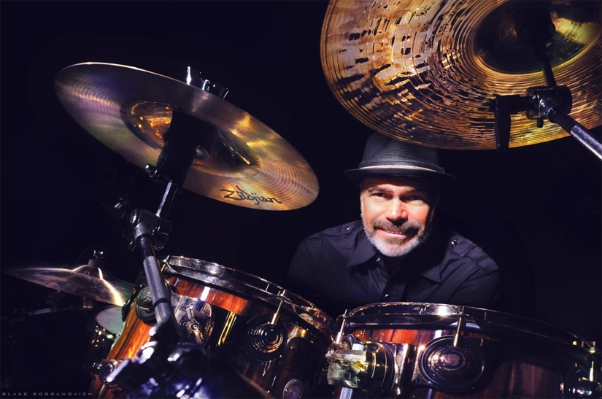
Danny Seraphine, at the office.

“ Overall, the project is exemplary in terms of the band's collective sound—a mixture of jazz, funk and solid original music for the new millennium.”
Belinda Ware ~ All About Jazz

“Danny Seraphine is one of the world's most highly-respected rock drummers, rated by the legendary Buddy Rich as one of his favorite young drummers. Danny's innovative integration of jazz chops with a rock feel and arrangements has been cited as a major influence in many of today's great drummers. Simply put: Danny Seraphine is one of the greatest drummers of all time.”
~ Zildjian

“It seems that since Danny Seraphine made a comeback of sorts of the 2006 Modern Drummer Festival, he’s kicked the current phase of his drumming career into high gear, appearing at events like Drummers for Jesus, the 2009 Chicago Drum Show, and a Terry Kath tribute, and making a memorable appearance at Donn Bennett’s Drum Shop in Seattle. Seraphine’s autobiography, Street Player: My Chicago Story, and new DVD, The Art of Jazz Rock Drumming, have also hit the shelves recently. MD sat down with the legendary drummer to find out more about his latest projects.”
Bob Girouard ~ Modern Drummer Magazine

Ex-Chicago drummer Danny Seraphine plays in a style that, ironically perhaps, can best be described as lyrical. "To be a good drummer," he explains, "one must develop his own technique. Good timing and good taste is essential, but it is the technique that sets the truly great drummers apart from the rest." Danny believes that Chicago's most significant contribution may be in its inspiration to others. He is hopeful that Chicago will inspire other musicians to be aware of the possibilities available through the use of imagination and open minds toward forms of music other than their own.
~ Drummerworld
Social Media Links:
Website - https://www.dannyseraphine.com/
Facebook - https://www.facebook.com/DannySeraphineOfficial/
Instagram - https://www.instagram.com/dannyseraphine/
Twitter - https://twitter.com/dannyseraphine

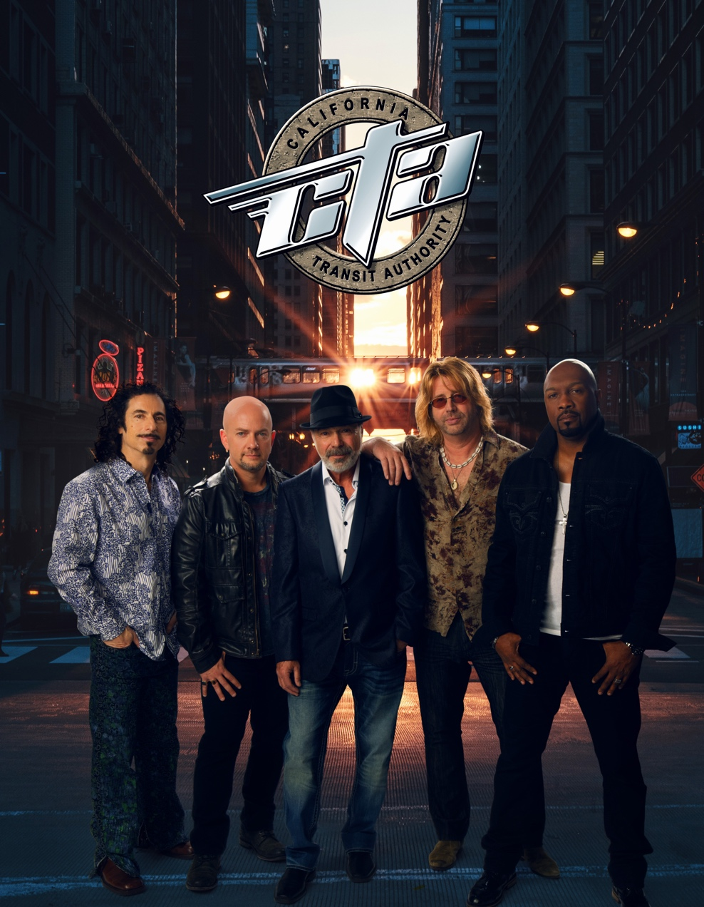

Booking Contact: Joel Brandes joel@universalattractions.com 424-248-5705

